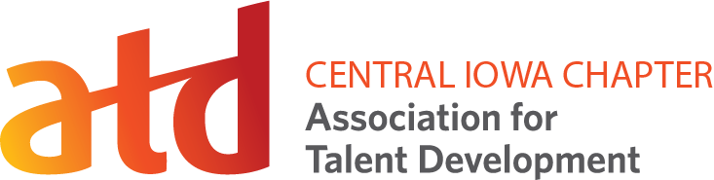

Professional Development Day
February 2, 2024
Session Worksheet
Sessions:
I plan to attend the following sessions to strengthen my professional development. (Mark the sessions you plan to attend as well as the learning outcomes and how they will benefit you, your team, and your organization. Please refer to the schedule of events as some sessions and round tables run concurrently).
Plan To Attend | Session Title | Speaker | Benefits and Learning Outcomes
Track 1: Integrated Talent Management, Managing Learning Programs, Knowledge Management
 | Skills Revolution: The Skills-Driven Future of Talent Development | Joey Spivey, Wellabe
 | Redefining Your TD Role: From Functional Expert to Strategic Leader | Carlos Rojas, 2.0 and Gina Brown, Magnify Innovation and Leadership
 | Augmenting Learning and Performance with AI | Thom Powell, Value People, and Gerard Krupke, BSB Design
 | Feed the Beast: How to Win on Social Media with Engaging Kick*ss Content | Joshua Scheinblum, Five Seasons Media
 | From the Public School to the Private Sector: Teacher to Corporate Trainer | Alan Feirer, Group Dynamic
Track 2: Performance Improvement, Change Management, Coaching
 | Culture & Learning: The Catalyst for Employee & Customer Engagement | Katherine Phillips-Parrish, Phillips Learning Design
 | L&D Consulting in a Vending Machine World | Denise Kyle-Needs and Jacey Beukelman, Farm Bureau Financial Services
 | Leveraging Coaching When Working with Subject Matter Experts | Jacque Hollingshead and Katelyn Proctor, Mary Greeley Medical Center
 | How to Make Development Assessments a Better Investment | Dick Hannasch, Aware and Willing, LLC, and Roxy Galkin, ChildServe
 | The Key to Increasing Learning Performance – Psychological Safety | Molly Mackey, LEAdeRNship Institute
Track 3: Training Delivery, Instructional Design, Learning Technologies, Evaluating Learning Impact
 | Power Up with Power Apps | Mary Roth and Elizabeth Kinsey, Principal Financial Group
 | Things We Don’t Know We Don’t Know: Managing Skills and Talent Development | Dr. Jeffrey Kappan and Stephen Smith, Baton Global
 | Level Up Your Organization’s Measurement and Evaluation Culture | Jon Pederson, Principal Financial Group
 | A Higher Education Perspective or Collaborating with Subject Matter Experts | Dr. Long He and Hiro Iino, Iowa State University
 | Making Learning Stick: Why Training Can Fall Short and What to Do About It | Dr. Teresa Peterson, Sarah Noll Wilson, Inc.

